**PART A – SERVICE PROVIDER SIDE WEBPAGE**

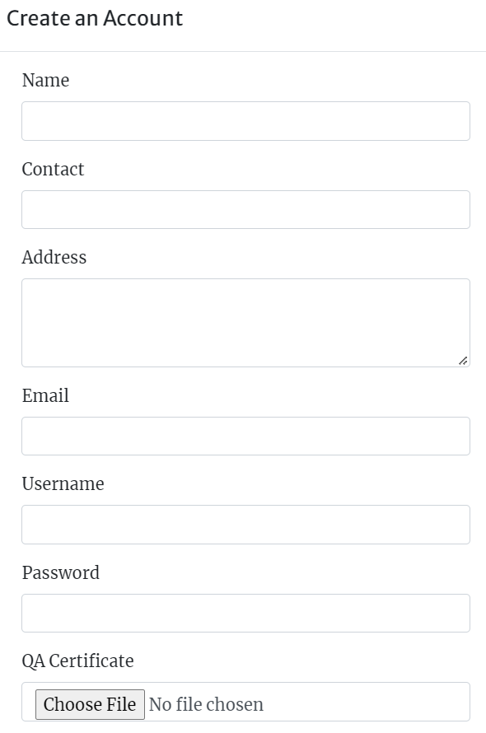

**FIG 1 : SIGNUP FORM**

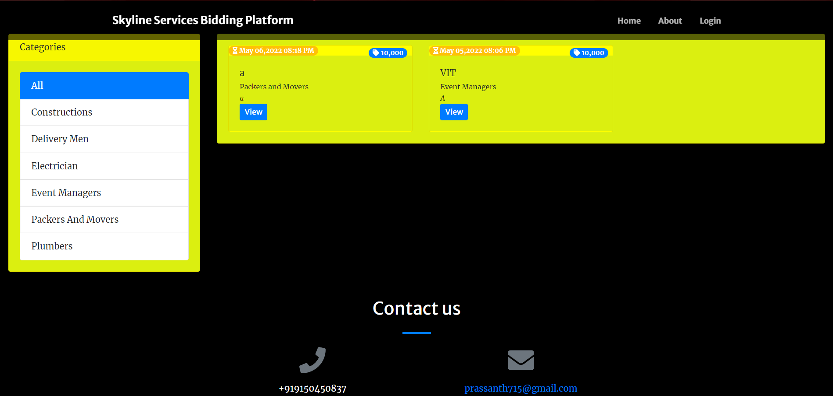

**FIG 2 : HOMEPAGE**

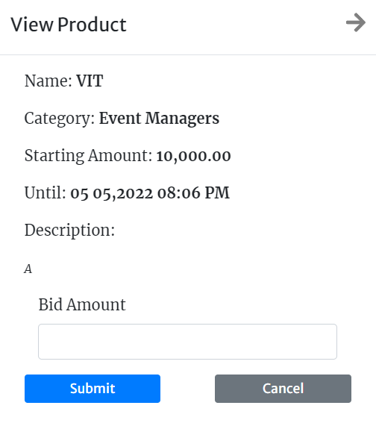

**FIG 3 : BIDDING PORTAL**

**PART B – CONSUMER SIDE WEBPAGE**

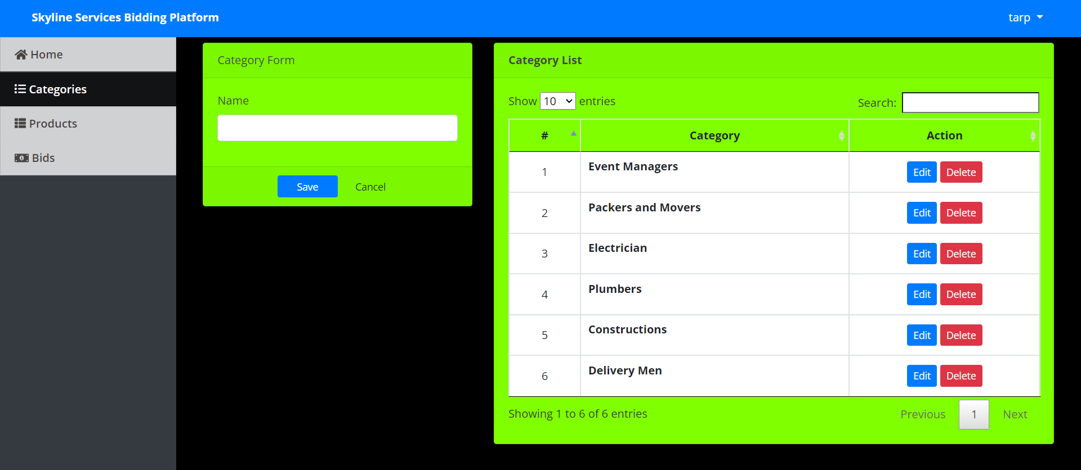

**FIG 4 : CATEGORY OF SERVICES PAGE**

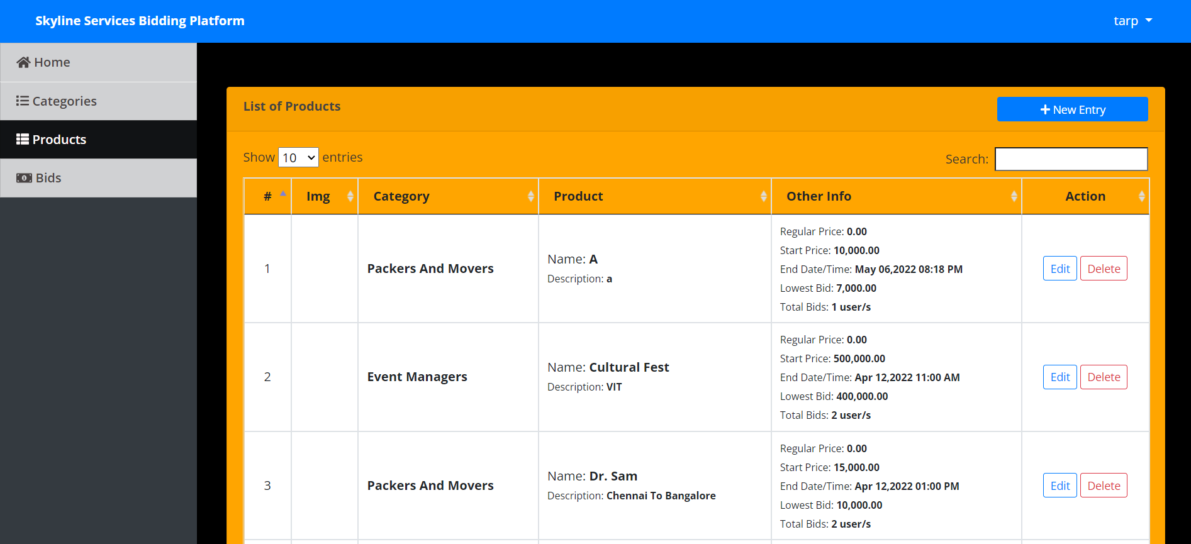

**FIG 5 : SUMMARY OF SERVICES**

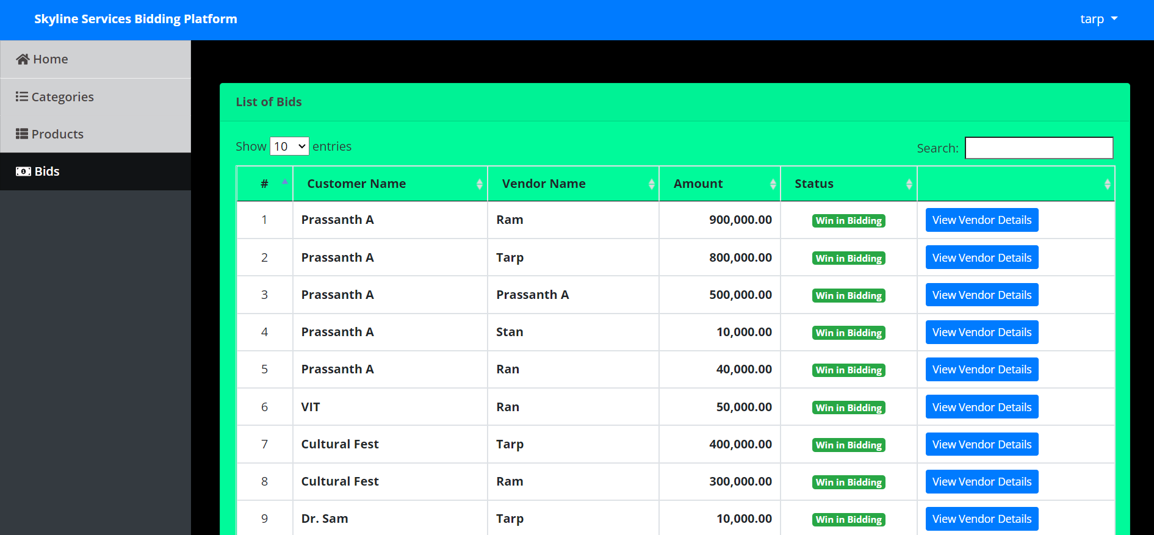

**FIG 6 : SUMMARY OF CURRENT AND WINNING BIDS**



**FIG 7 : VENDOR DETAIL OF THE ONES WHO MADE A BID**

**PART C – DATABASE**

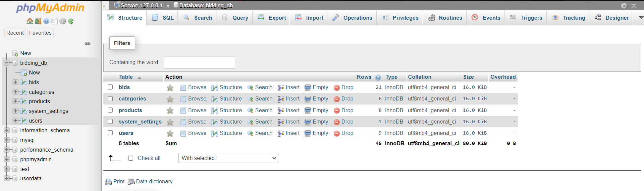

**FIG 8 : OVERALL DATABASE OF WEBSITE**

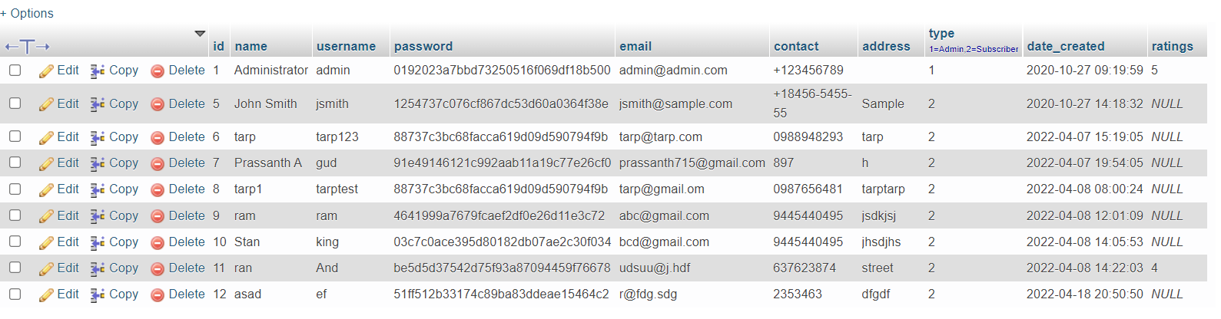

**FIG 9 : SERVICE PROVIDER DATABASE**

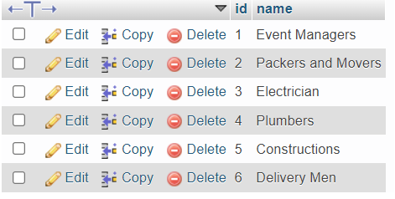

**FIG 10 : DATABASE OF CATEGORIES**

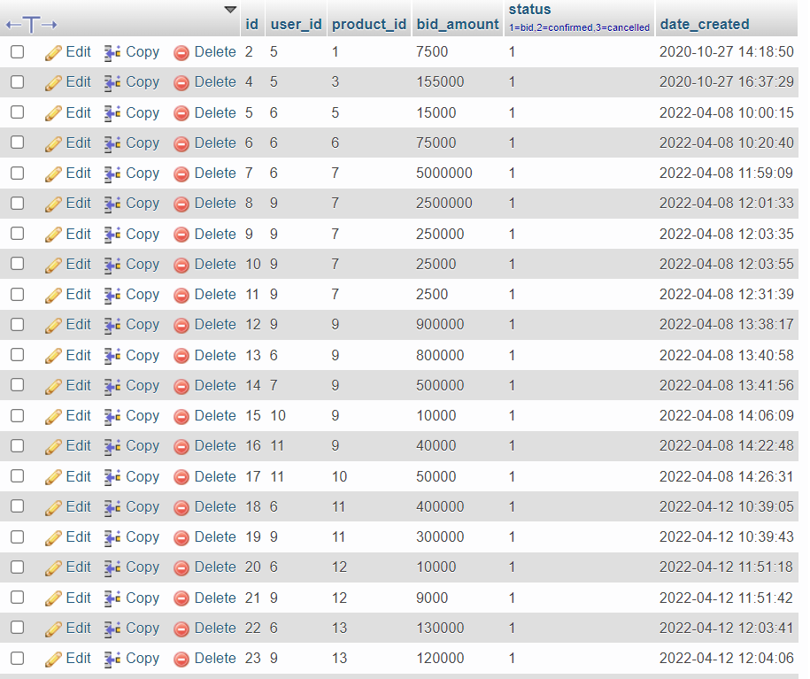

**FIG 11 : DATABASE OF BIDS**

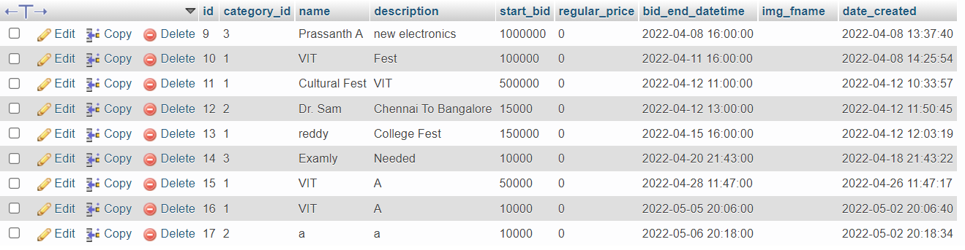

**FIG 12 : DATABASE OF SERVICE REQUIRMENTS POSTED**



**FIG 13 : DATABASE OF BASIC WEBSITE INFO**